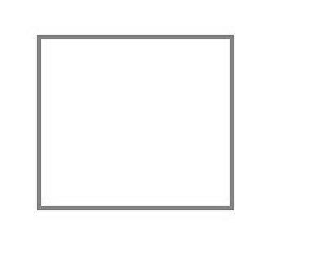     

**Shoes** to walk on sidewalk

**bike**

car and **truck** road

**truck**

**Bike** trail

water **boat**

**train** track

**train**



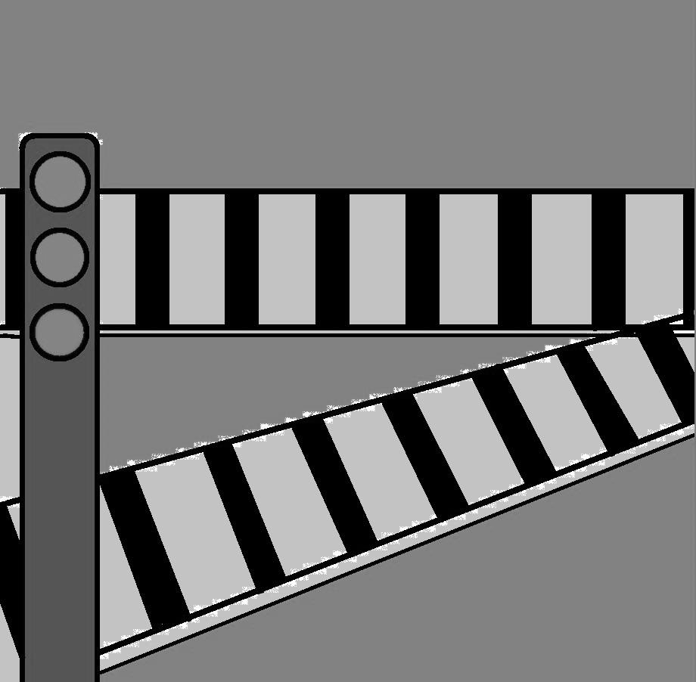

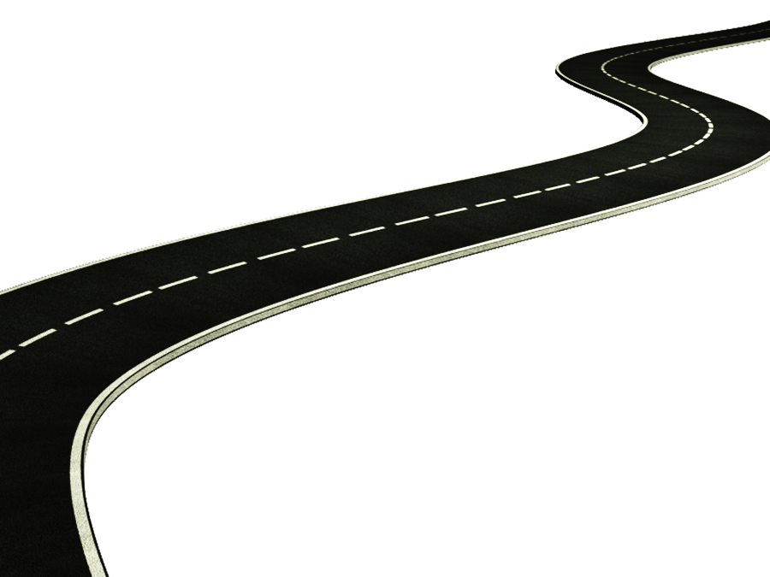



[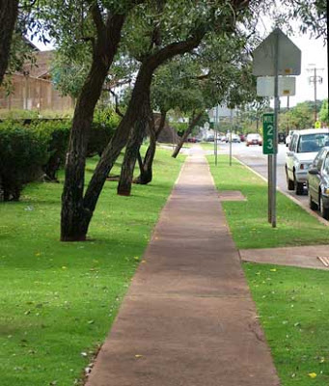](http://1.bp.blogspot.com/-KE7d_YNE1hw/UKEPC_KX74I/AAAAAAAAFYY/z1oihiCPQL4/s1600/sidewalks.jpg)



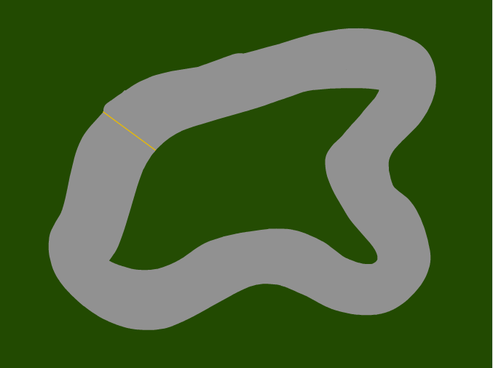



Cut out squares on right side of both pages above (road,tracks,etc). Tape left sides of papers to inside of file folder—one on each side. Place the modes of transportation sides (left side of pages above) inside laminate sheet & laminate. Cut them apart & store in an envelope. Children will match the cut out cards to the mode of transportation pictures.

**boat** goes on the water

race **car**

**bus**

ride the **bus** to school

**airplane**

**airplane** flies in the sky

race **car** track

walking **shoes**





[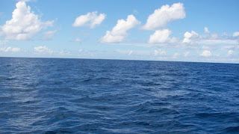](http://1.bp.blogspot.com/_Y0vjsWbfIq8/S-O4FjXhGXI/AAAAAAAAAA8/b8OlKlDhNew/s1600/oceans_alive.jpg)



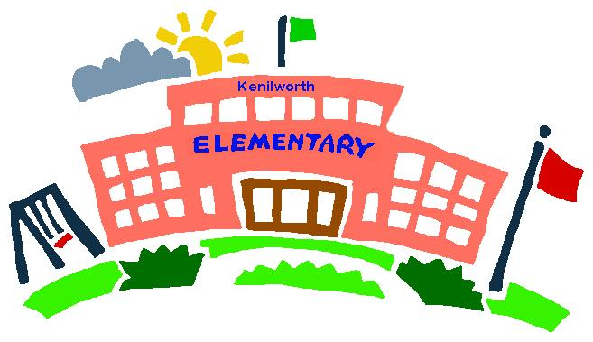





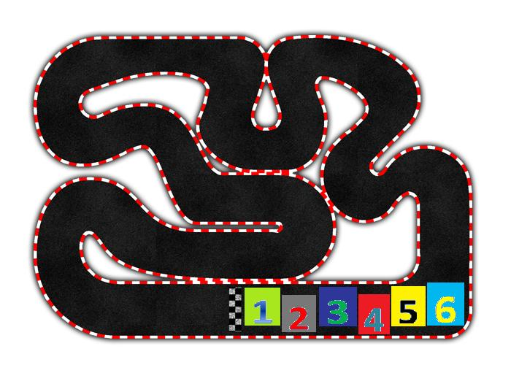



Skill: Learning about various modes of transportation.

Includes: 8 transportation cards and 8 “roadways”.

How to Play: Match the modes of transportation cards to the correct

“roadway”.

*Teacher tip: Understanding methods of getting from one place to another is an early skill necessary to comprehend how our society functions.*

*Include toys related to methods of transportation into play areas. Discuss the need to transport goods and people.*



How Do We Get There?

Tape the above title page to the front of the file folder. After laminating the folder, tape the envelope to the front of the folder, under the title page.

