**[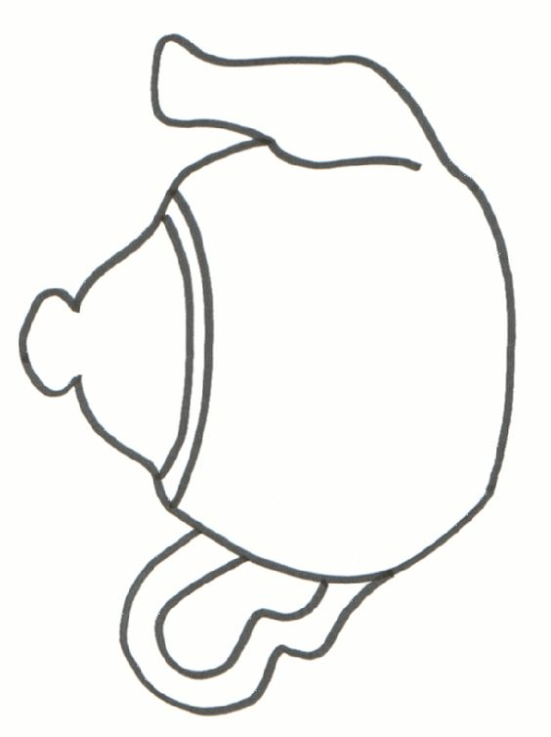](https://www.pinterest.com/pin/97671885641135310/)**

I’m a Little Teapot

I’m a little teapot short and stout

Here is my handle, here is my spout.

When I get all steamed up then I shout

Tip me over and pour me out.

**Can your child match the teacups to the teapot with the same pattern?**

Teapot and cups Activity - Matching patterns for beginning learners

**To Play**: Lay out one teapot.

* Scramble all the cups in front of the learner.
* Ask them to find two cups that match the teapot.
* When they find the two cups, put the teapot and two cups in the “cupboard” (the inside pockets of your folder).
* Continue with the game in the same manner until all the teapots and cups have been matched and they have been put back in the cupboard.

*This activity helps beginning learners become familiar with patterns and develop the skill of matching patterns. It helps them to visually discriminate things that are the same and things that are different. Learners become familiar with recognizing patterns in “print”. Alphabet letters all have different patterns or shapes in print.*

Pocket folder works best. Make 8-10 different designs. I use scrapbook tablets 81/2 x 11 size. Make copies of this page. Laminate-optional. Cut out. Store in envelopes—one for teapots and one for tea cups.

Cut out the first page as you wish it to look on the outside of the folder.

Appropriate for ages 2 - 5.

[](https://www.pinterest.com/pin/97671885641135310/)

[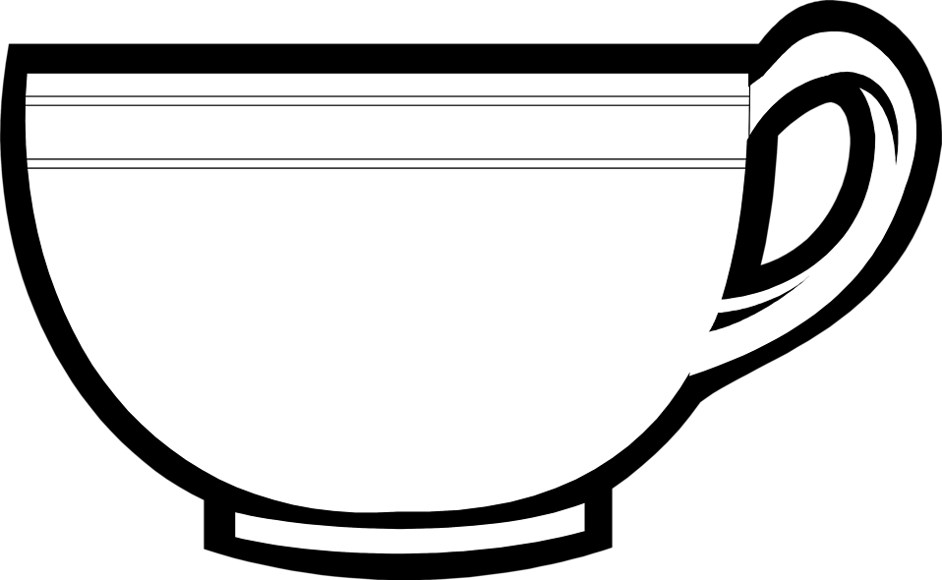](http://cliparts.co/tea-cup-clip-art-free)

