[[](http://clipartix.com/wp-content/uploads/2017/05/Quarter-coin-clip-art-clipartfest-rest.gif)](http://clipartix.com/wp-content/uploads/2017/05/Quarter-coin-clip-art-clipartfest-rest.gif)

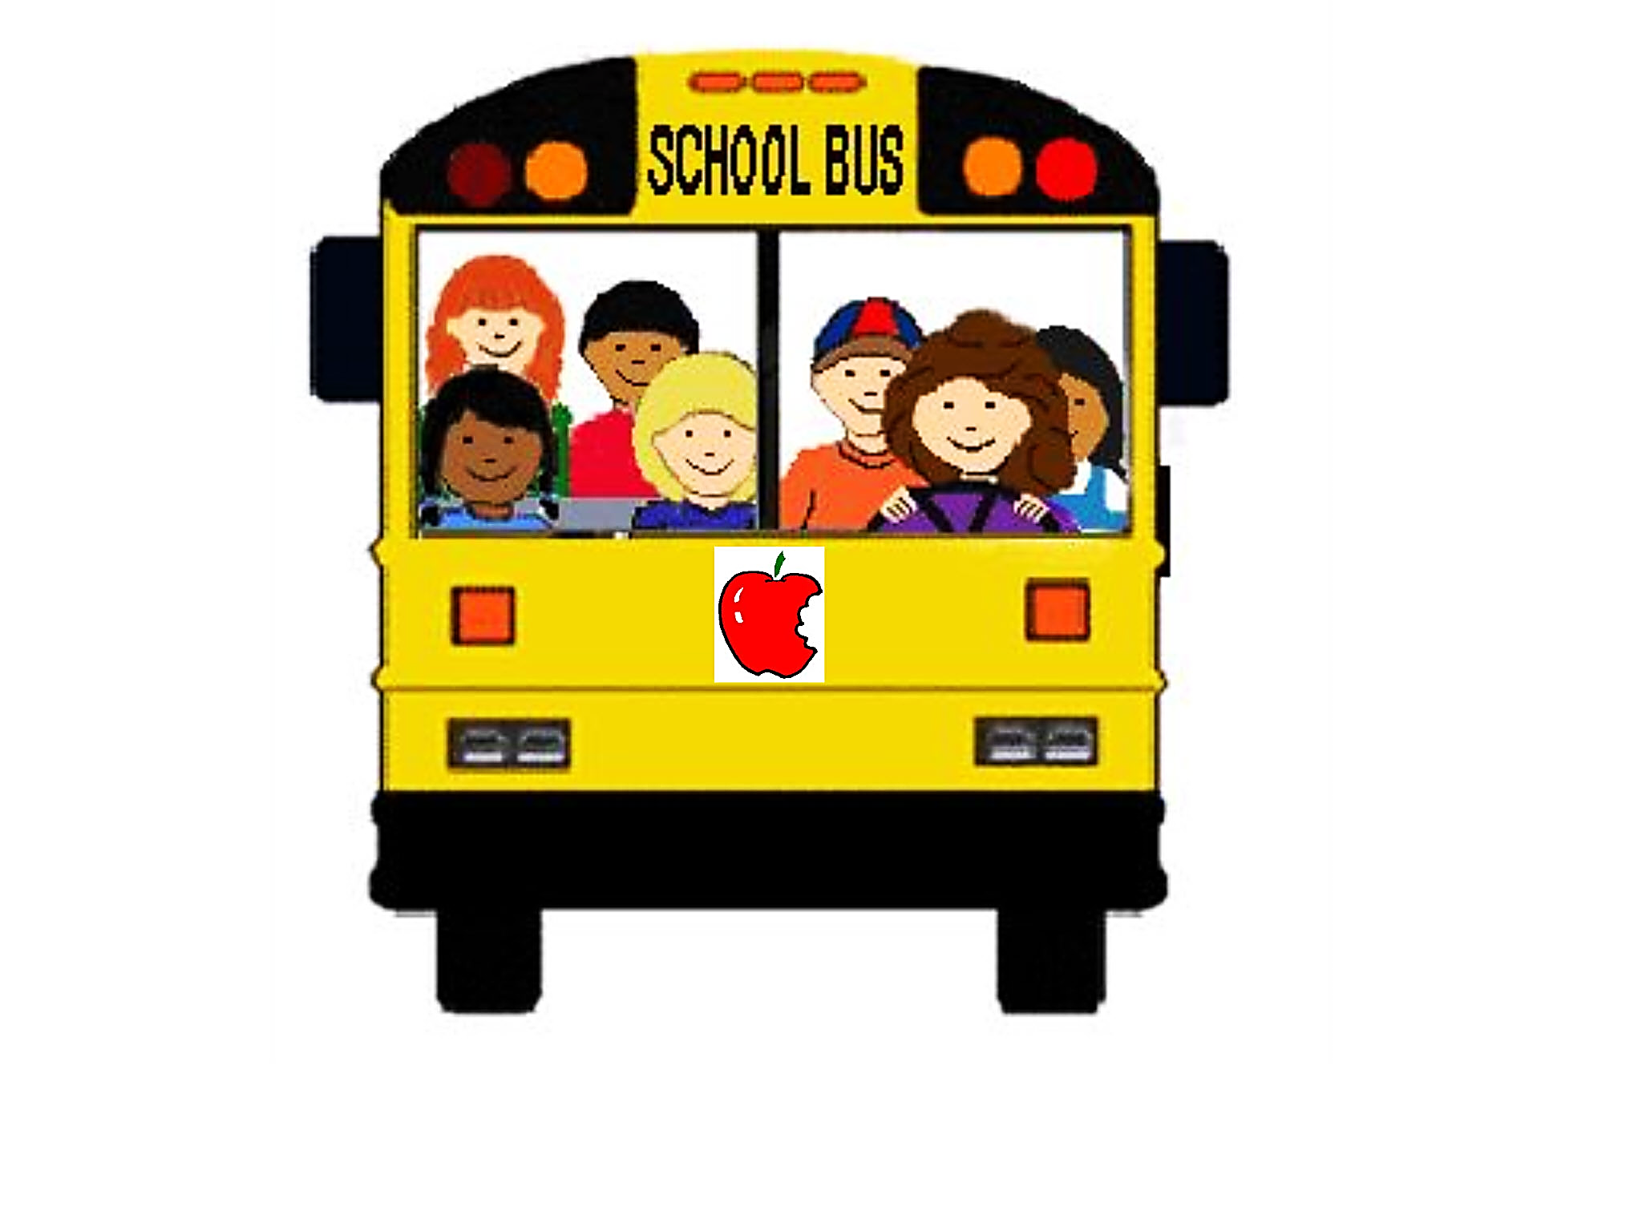

The **people** on the bus

The **baby** on the bus

[](http://www.freeclipart.pw/uploads/2017/05/crying-baby-clipart-28.jpeg)

This is the **bus**

[](http://www.clker.com/cliparts/Z/1/L/2/Q/I/big-blue-bus-md.png)

[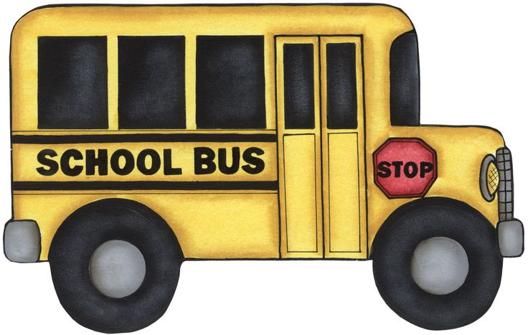](https://s-media-cache-ak0.pinimg.com/736x/d6/7e/43/d67e4389cc3c4ea9a8e44363f77ef978.jpg)

The **door** on the bus

[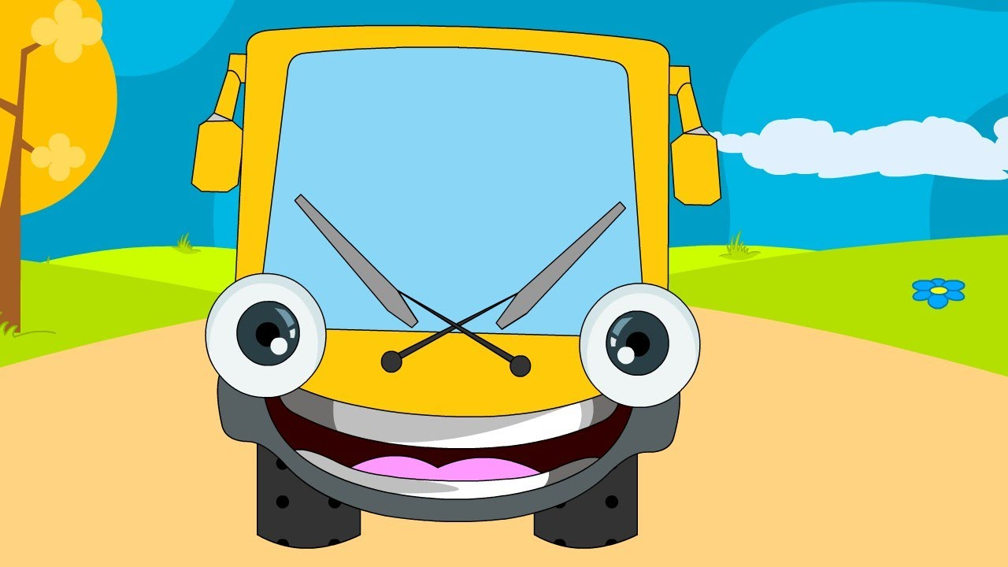](http://cherieladie.com/wp-content/uploads/2014/03/bus-wipers.jpg)

The **wipers** on the bus

[](http://1.bp.blogspot.com/-e0TXD7RTGSs/USnmUyNBg0I/AAAAAAAAAUs/A4H4hPG7e4I/s1600/Horn.png)

The **horn** on the bus

[[](http://www.clipartbest.com/cliparts/xcg/o5e/xcgo5en7i.)](http://clipartix.com/wp-content/uploads/2017/05/Quarter-coin-clip-art-clipartfest-rest.gif)

The **wheels** on the bus

The **money** on the bus



**The Wheels on the Bus Puzzles**

[](http://www.clker.com/cliparts/Z/1/L/2/Q/I/big-blue-bus-md.png)

Place the title page on the front of the folder. Laminate the two pages of puzzles. Cut the puzzle pieces apart.

Store the smaller pieces in an envelope taped to the outside of the file folder—below the title page. Tape the

larger pieces to the inside of the folder as shown in the *picture Note: If you are laminating the folder, tape the*

*Envelope to the folder AFTER laminating. Best for ages 5 to 7*

