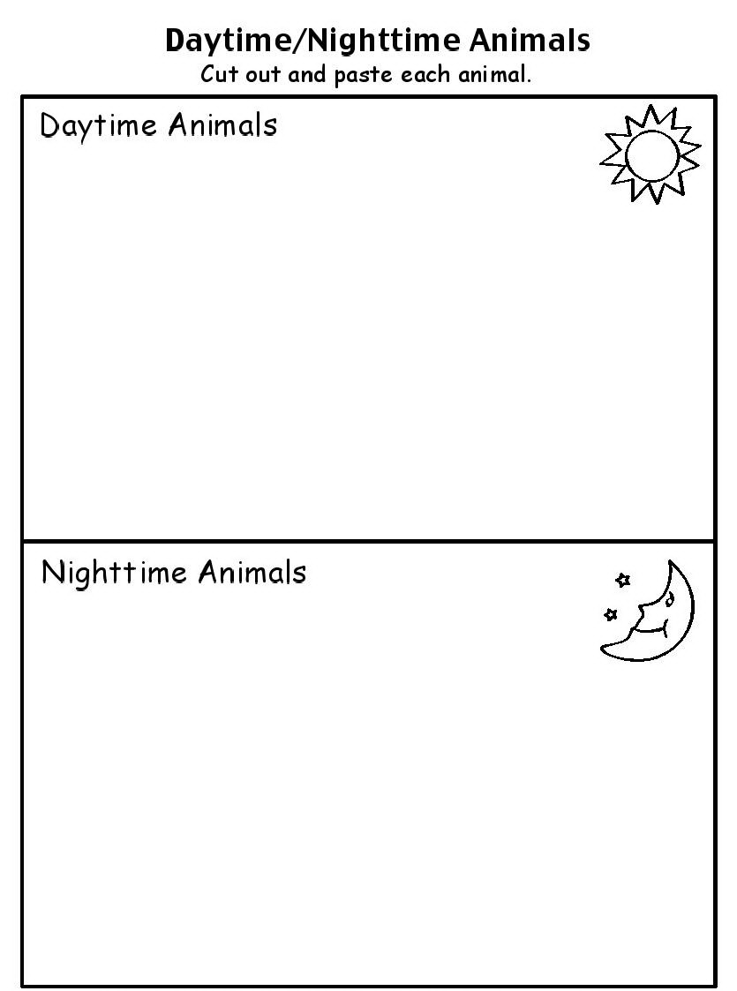

Farm Animals







Zoo Animals

Classifying Zoo Animals and Farm Animals Game

Directions: Remove the cards from the envelope, shuffle the cards, and lay them upside down on a pile (as a deck of cards). Make sure the deck is within easy reach of the children. Each child takes a turn pulling a card off the deck.

* Can they identify the animal by name. Help them if necessary.
* Can they identify the animals as a farm animal or a zoo animal?
* Have them place the animal card on the appropriate page (far or zoo page.
* Continue playing in this manner until all the cards are placed either on the zoo page or the farm page.

*Note: Sorting and classifying objects not only teaches children about attributes and relationships, but also promotes thinking logically and applying rules. These type of exercises can provide children with models for organizing things in the real life experiences, such as putting toys away or setting the table for dinner.*

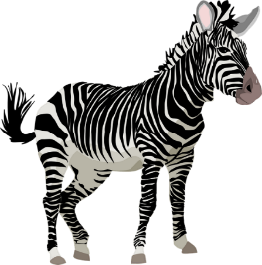[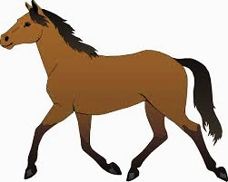](http://marnemessage.blogspot.com/2014/11/marne-message-for-nov-6.html)

Making the folder: Cut out the title page and place on the front of the file folder. Copy the cards on cardstock, laminate, cut out each card individually. Place them in an envelope and place on the outside of the folder, under the title page.. (If laminating the folder, tape envelope on the after laminating)

Glue the two pages (farm and zoo) on the inside of the folder. Laminate the folder (optional).

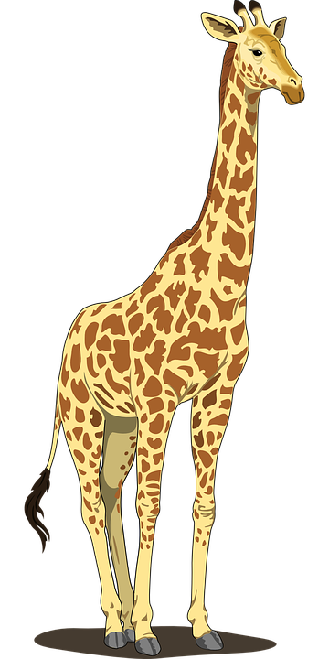

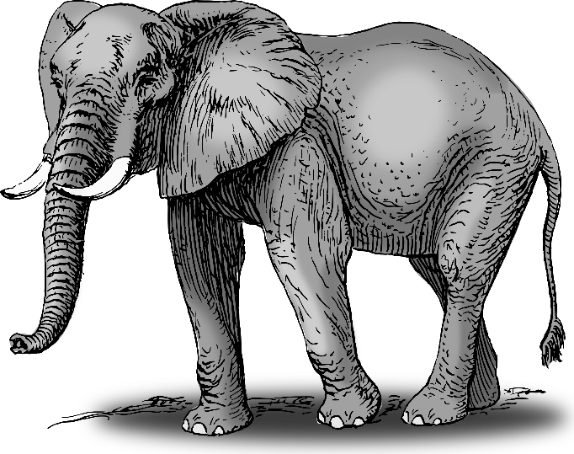[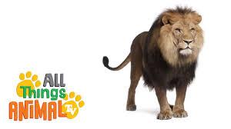](https://www.youtube.com/watch?v=PlwCtdiF0hI)

lion

[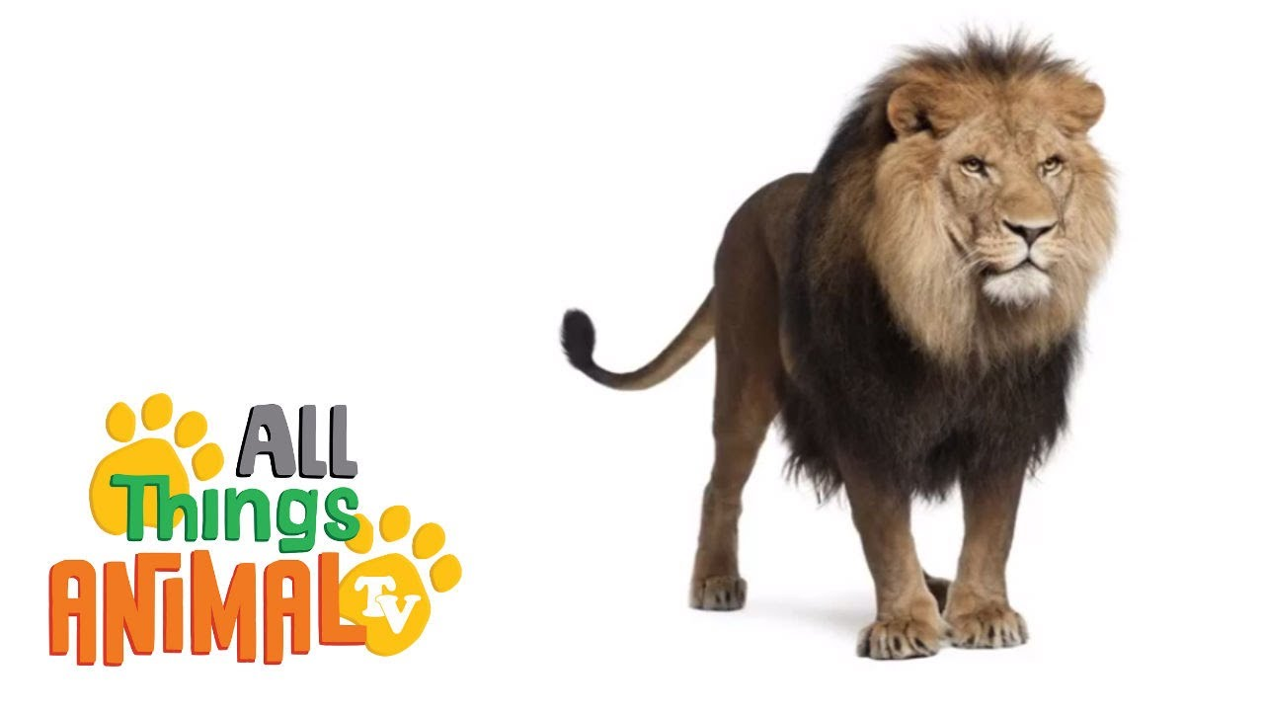](https://www.youtube.com/watch?v=PlwCtdiF0hI)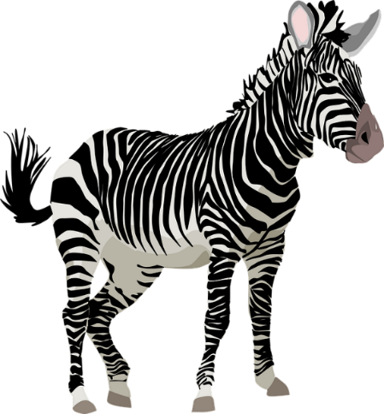

giraffe

zebra

elephant

fox

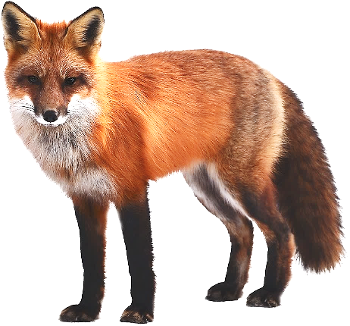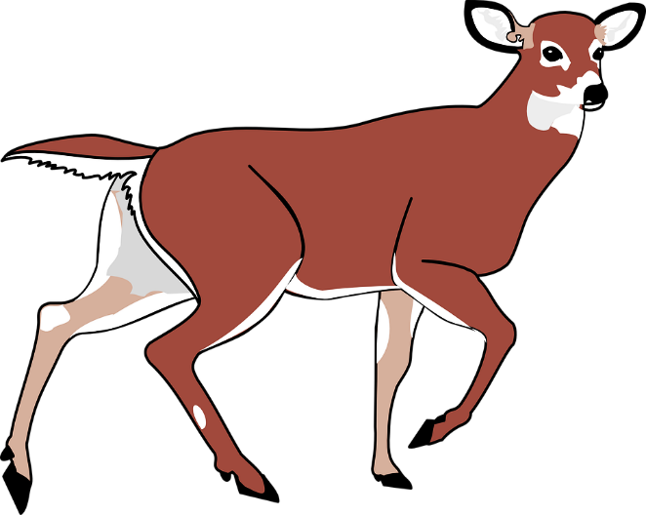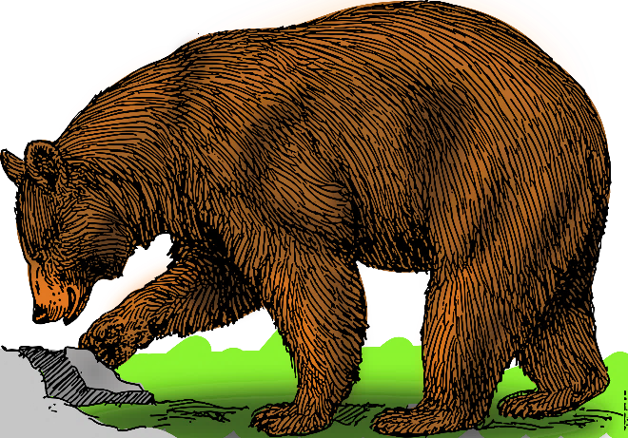[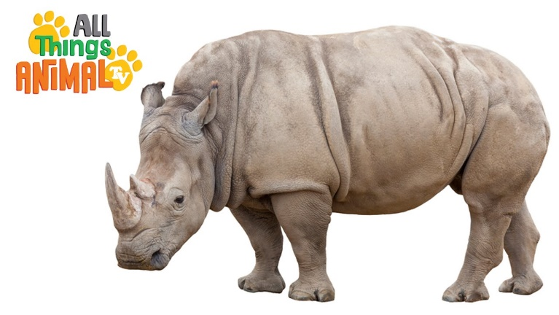](https://www.youtube.com/channel/UCB_2_OiPFh6FdUvp50_maug)

deer

rhinoceros

bear

[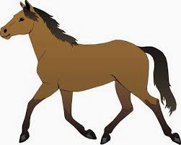](http://marnemessage.blogspot.com/2014/11/marne-message-for-nov-6.html)

chicken

turkey

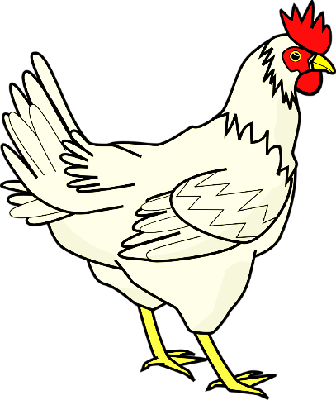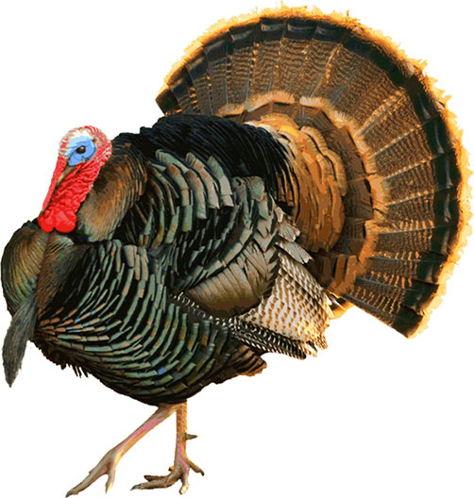[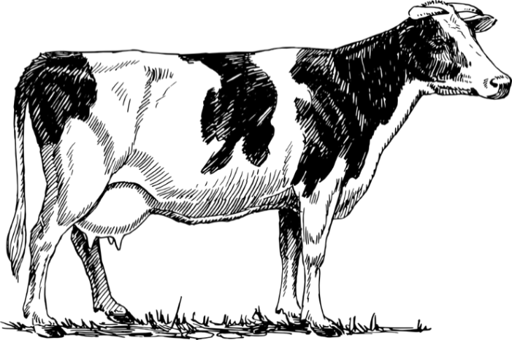](https://pixabay.com/en/photos/cow/?image_type=illustration)

cow

horse

Cut cards apart and store in envelope

sheep

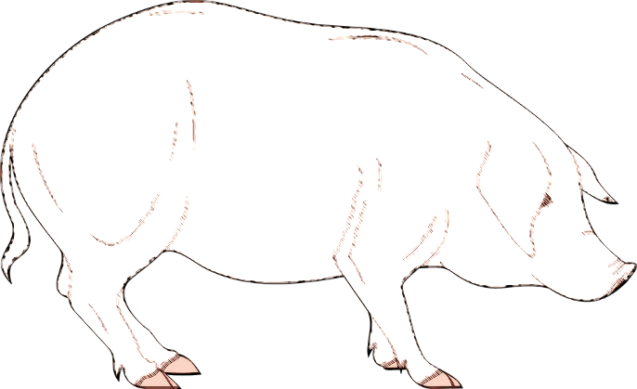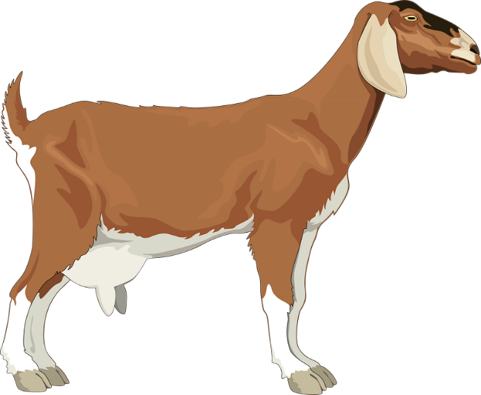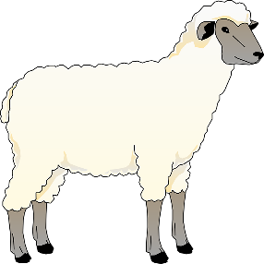[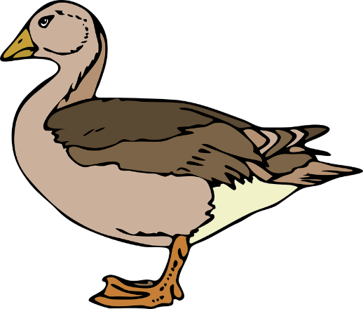](https://pixabay.com/en/photos/rybnik/?image_type=illustration)

duck

pig

goat

