**[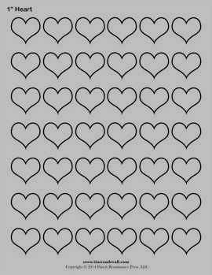](http://timvandevall.com/geometric-shape-templates/heart-templates/)**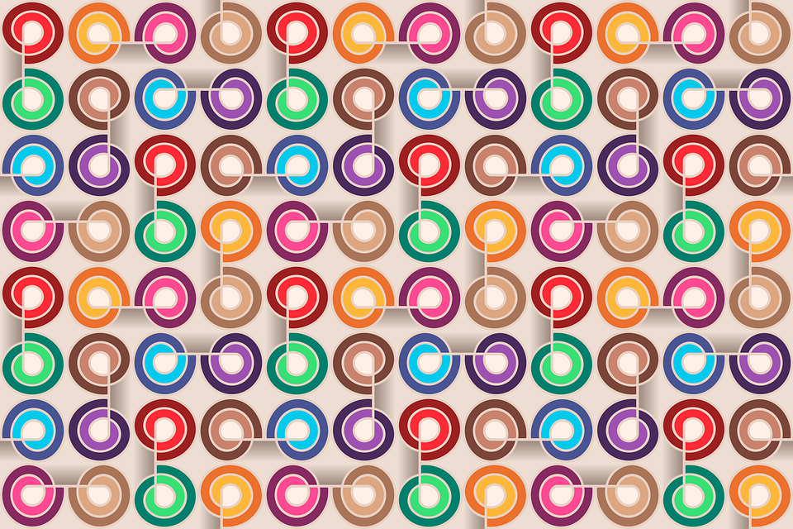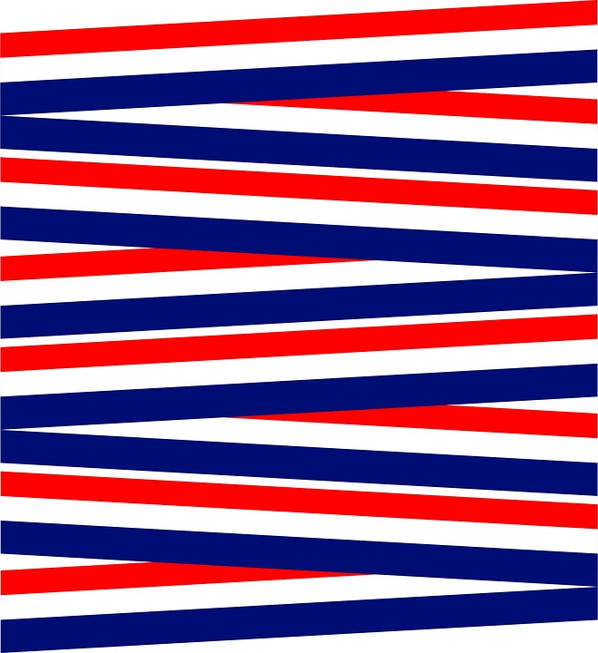[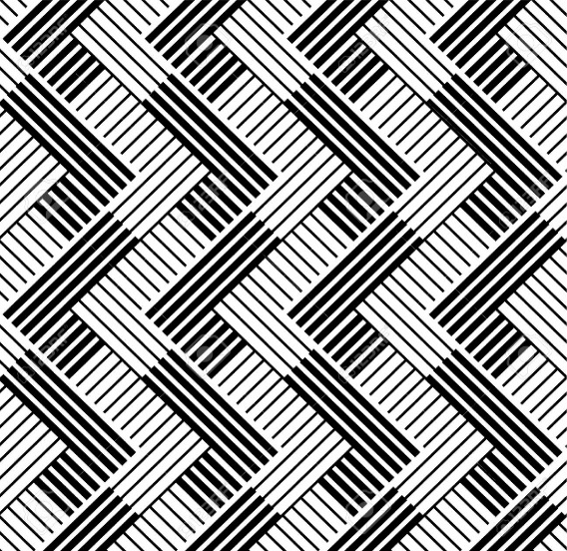](http://www.123rf.com/photo_15077904_pattern-with-line-black-and-white.html)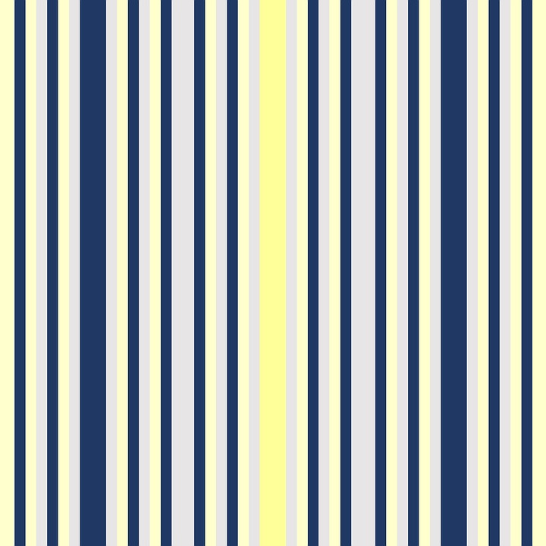

[](http://society6.com/carleyleedesign/Grey-or-Gray_Stretched-Canvas)

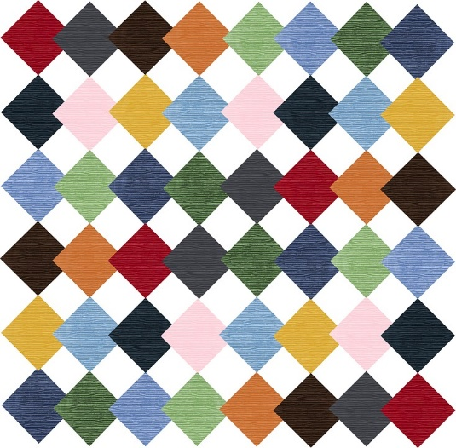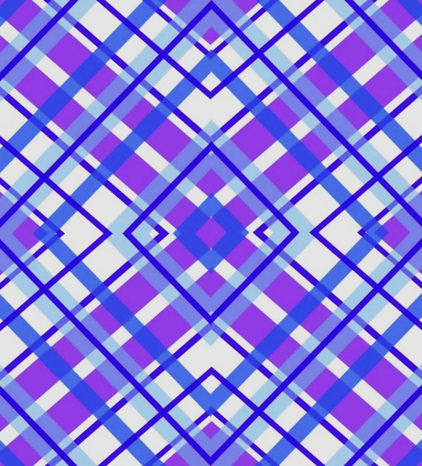

×

Cut out the above heart. Use it as a template to make white hearts to be placed as shown in the picture.

I cut a sheet of white paper into four strips. Using the template, copy three hearts on the strips. Makes it easier to cut out only 3 times instead of 12 separate hearts.

Glue them to the hearts inside the folder as shown on the picture.

Crazy Heart Patterns

Visual Discrimination Activity for Children ages 5 to 9

Visual discrimination is the ability to identify differences in visual images. Many parts of a preschool or kindergarten classroom use visual imagery, including: 1) Reading and writing; 2) Mathematics;

3) Social studies and science, and Social interactions.

**Activity:**

* Take out the hearts inside the envelope and lay them to the right side of the folder.
* Can you match your hearts to the ones in the folder?

Directions for making the file folder:

* Tape the directions on the front of the folder
* Make two copies of hearts page
* Cut out the hearts on one page and store in an envelope.
* Cut out the hearts on the other page and tape them to the inside of the folder (as shown on the picture).
* Laminate the folder.
* Tape the envelope with the cut-out shapes on the outside of the folder.
* Ready to use!

Optional: You can add magnetic tape to the back of the hearts in the envelope and the white hearts inside the folder. It makes it a little easier for children to use.

Sample picture:

