*File Folder activity: Place Tangrams description on outside of folder, place Tangram Puzzle Pictures and Question on inside, left side of file folder. Cut the tangram pieces apart and store in envelope—place inside the folder below the Question. Place the strip of sample shapes (house, castle, cat….etc) inside the folder on the bottom of the right side.*

*Most appropriate for ages 6 and above*

Tangram shapes: 1 square, 2 large triangles, 1 medium triangle, 2 small triangles, 1 parallelogram-7 total

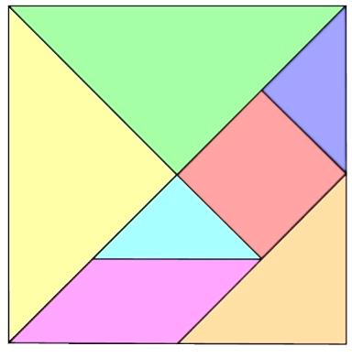 **Tangrams**

A tangram is a picture made up of seven shapes- square, triangles, and parallelogram. Tangrams promote recognition of shapes, problem solving, imagination, creativity, perceptual skills, fine motor skills, and builds a child’s attention span and persistence.

**Tangram Puzzle Pictures inside!!**

Place on inside of folder, on the left-hand page.

**Tangram Puzzle Pictures**

Take the Tangram pieces out the envelope. Spread them out so they are easily seen.

Use the space above the example pictures to create your own puzzle pictures with the tangram pieces.

**Question:**

Can you follow the sample patterns to make the puzzle pictures?

Cut on dotted line and glue strip inside the folder, on the right hand page. The space above will serve as a work mat.

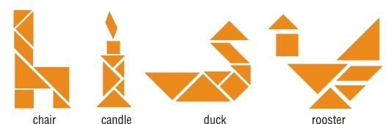



house castle cat chair candle duck rooster

Tangram pieces: print on colored cardstock, laminate, cut apart and store in envelope.

[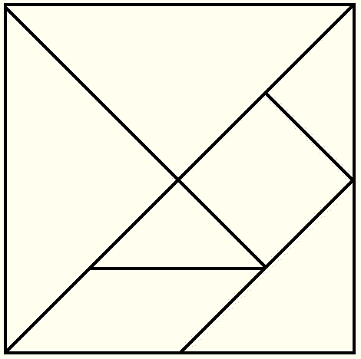](http://inevergrewup.net/chinese-tangram-for-kids/)

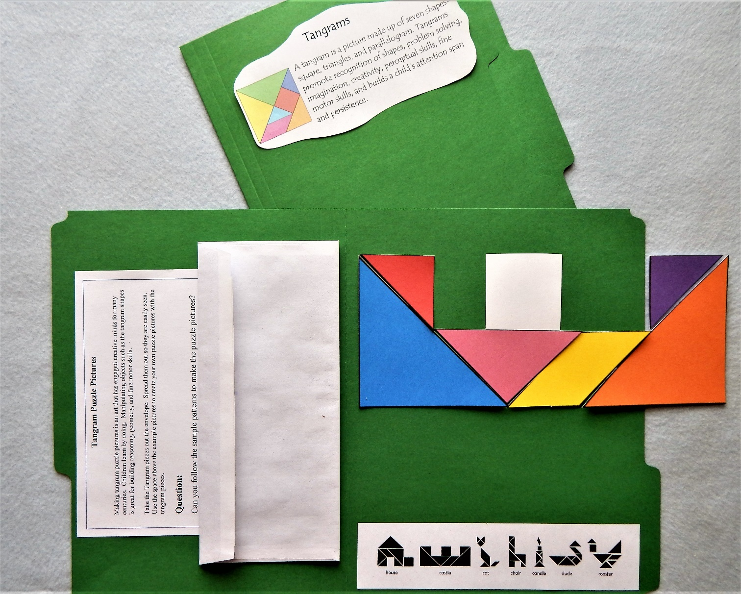[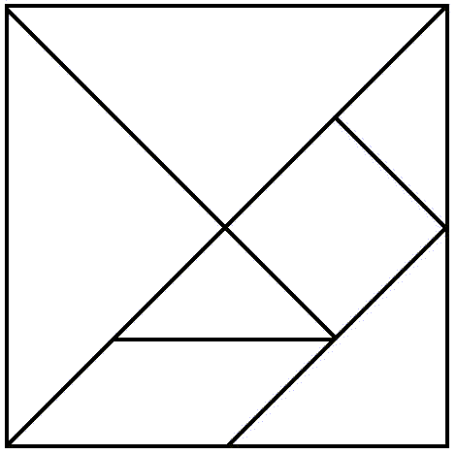](http://inevergrewup.net/chinese-tangram-for-kids/) Sample picture of file folder cover and inside layout.